UML DIAGRAM

CLASS DIAGRAM
A Class Diagram shows the static structure of a system by representing classes, their attributes, methods, and relationships such as inheritance and association. It helps in understanding the overall system design.
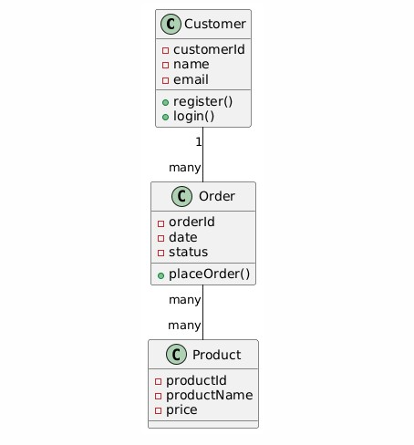

OBJECT DIAGRAM
An Object Diagram represents the real-time instances of classes at a particular moment. It shows how objects interact with each other using actual values, helping to visualize system behavior during execution.

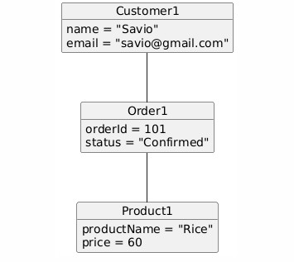

USE CASE DIAGRAM
A Use Case Diagram illustrates the functional requirements of a system by showing interactions between actors (users) and the system. It focuses on what the system does, not how it is implemented.

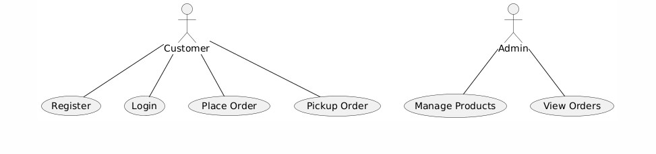

SEQUENCE DIAGRAM
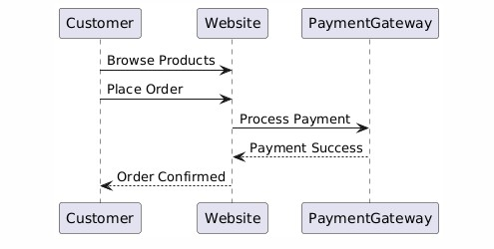
A Sequence Diagram shows the order of messages exchanged between objects over time. It helps in understanding the flow of control and interaction sequence for a specific functionality.

COLLABORATION DIAGRAM
A Collaboration Diagram (Communication Diagram) emphasizes object interactions and relationships. It shows how objects work together to perform a task, focusing more on links than time order.
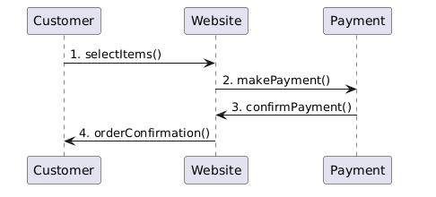

ACTIVITY DIAGRAM
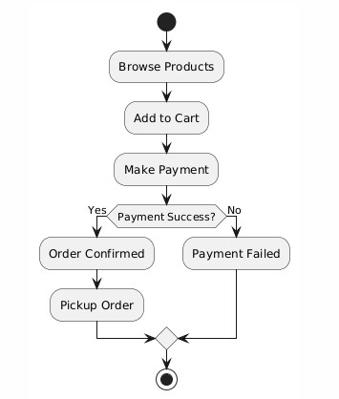
An Activity Diagram represents the workflow of activities in a system. It shows decision points, parallel activities, and process flow, making it useful for modeling business logic.

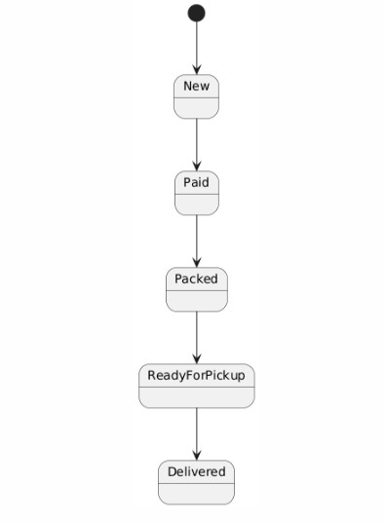
STATE CHART DIAGRAM
A State Chart Diagram describes the different states of an object and the transitions between those states based on events. It is useful for modeling dynamic behavior of a system.

DEPLOYMENT DIAGRAM
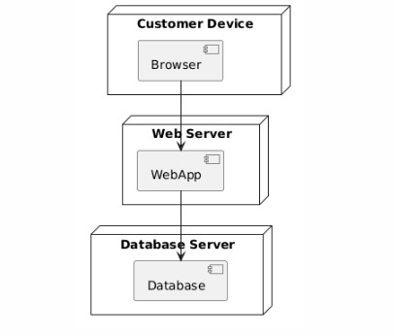
A Deployment Diagram shows the physical architecture of the system, including hardware nodes, software components, and their connections. It helps in understanding system deployment.

COMPONENT DIAGRAM
A Component Diagram illustrates the organization of software components and their dependencies. It helps developers understand module structure and system integration.
